New York State ASA District 7 Invitational
Girls Fastpitch Softball
Official Tournament Entry Form
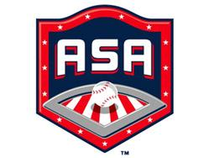

Miss Scotties Softball Fall Tournaments 2019 (circle one)

12u B: October 5-6 14u Open: October 12-13 10u B: October 19-20

TEAM NAME: (to appear on t’shirt)

MANAGER/COACH NAME:

MAILING ADDRESS:

PHONE NUMBER: CELL PHONE:

E-MAIL ADDRESS:

$495 Entry Fee. Make checks payable to Miss Scotties Softball and mail check and form to Miss Scotties PO Box 457 Ballston Spa, NY 12020

Registration is on a first come, first serve basis, with your check holding a place for your team.

Official ASA Team rosters & proof of insurance must be in the tournament director’s hands 10 days prior to the start of the tournament, unless he/she advises otherwise.

Three game guarantee.
No metal cleats please.

Reimbursement Policy:
1. Full reimbursement if more than 60 days from tournament start date.
2. $100 admin fee applied: 31-60 days in advance of tournament.
3. No refund within 30 days of tournament.

Contact Registrationdirector@missscotties.org with questions or visit our website at www.missscotties.com

