

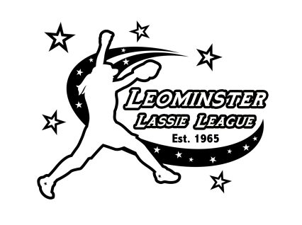
12U 2020 Halloween Havoc Softball Tournament
October 31st-November 1st Hosted by Leominster Lassie League

Tournament Director: Curtis Ruby 978-413-0209
Tournament Organizer & Scheduler: Dawn Grebinar 978-577-7852
Email : leominsterlassieleague@gmail.com

The tournament will consist of a 2 game pool play on Saturday and single elimination championship round.

Team Costume Contest on Saturday
Cost: $400 per team, Full Payment by September 1st.

Mail payments to Leominster Lassie League, PO Box 362, Leominster, MA 01453
Maximum teams: 8
Trophies: 1st & 2nd place teams
Location: Leominster Lassie League, Bassett Fields, 20 Bassett St., Leominster, MA 01453. The complex has 3 fields, concession stand, rest rooms and plenty of onsite parking.
*Dogs are allowed but owners must clean up after them and keep them on a leash at all times.

