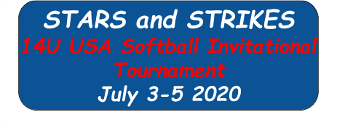
Easton, NY
Hosted By: Glens Falls Titans 14U - Blue

Full concession, raffle, t-shirts, on-site
Bathrooms, and plenty of room on site for teams to warm-up and set up tents for the day. Plus much more! (Covid Permitting)

Just minutes from Downtown Saratoga, Saratoga
Race Course, Six Flags Great Escape, and the
Lake George Outlet Malls.

$450.00 Tournament Fee, 4 Game - Single
Elimination, USA Softball Rules, Registration on a first come first serve basis.



TOURNAMENT DATES: 7/3-7/5

NAME OF TOURNAMENT: July 4th

AGE DIVISION: 14U - B

TEAM NAME: _____________

MANAGER/COACH NAME: _________________________________

MAILING ADDRESS:
_________________________________ _________________________________ _________________________________

PHONE NUMBER: ______________ CELL PHONE: _______________

E-MAIL ADDRESS:__________________________

A non-refundable registration​ fee as specified in the tournament announcement is due at the time this form is submitted. Make checks payable to host league and mail check and form to host
league as specified on announcement. Registration is on a first
come, first serve basis, with your check holding a place for your

team. ​Official USA Softball Team rosters, proof of insurance, photo
ID, and birth certificates must be in the tournament director’s hands 10 days prior to the start of the tournament, unless he/she advises otherwise.

All managers & coaches must be dressed alike, this includes shirts and pants in team colors.

